


An Assignment on

FingerPrint Authentication

Submitted in Partial Fulfillment of the Requirement

for the IV Semester MCA Academic
ADVANCED COMPUTER NETWORK ASSIGNMENT
18MCA452

MASTER OF COMPUTER APPLICATIONS
By

USN | STUDENT NAME
1RV19MCA01 | Abhijith R

Incharge
Dr. Deepika k
Assistant professor
Department of Master of Computer Applications
RV College of Engineering®, Mysuru Road
RV Vidyanikethan Post, Bengaluru – 560059
June -2021

Designs

activity_main.xml

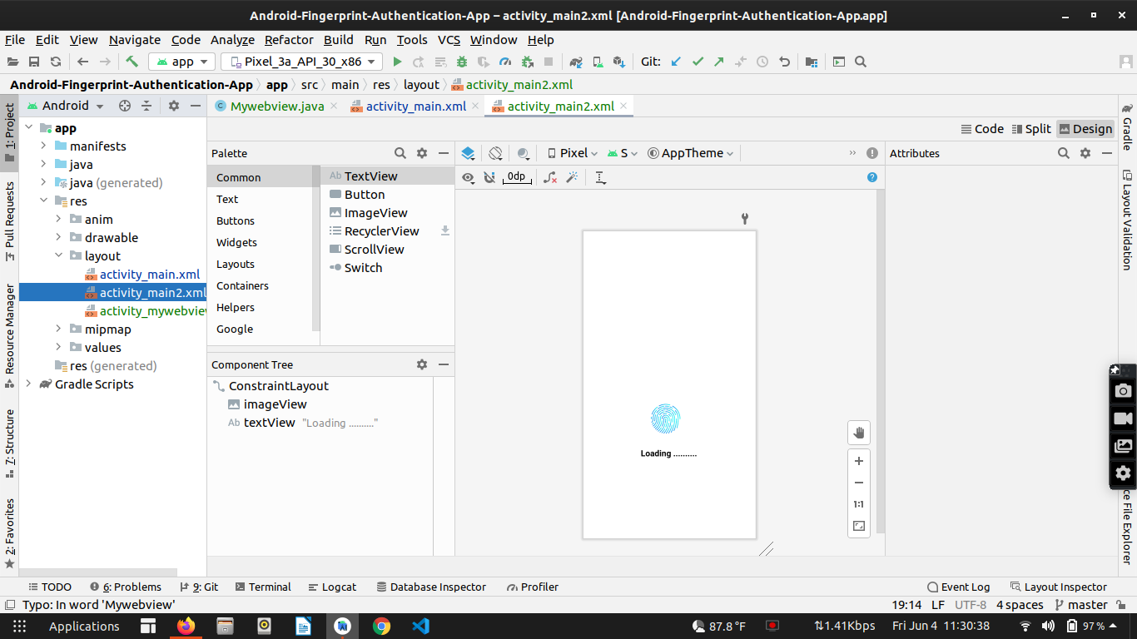

activity_main.xml

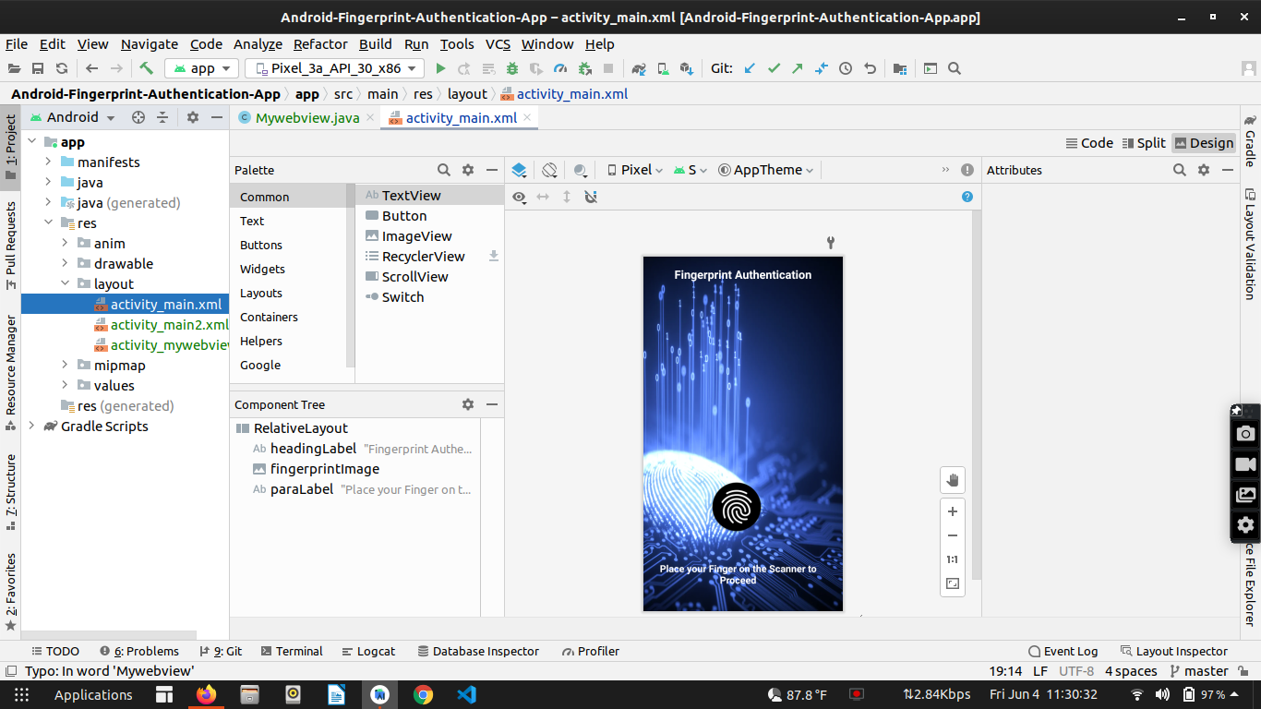

AndroidManifest.xml

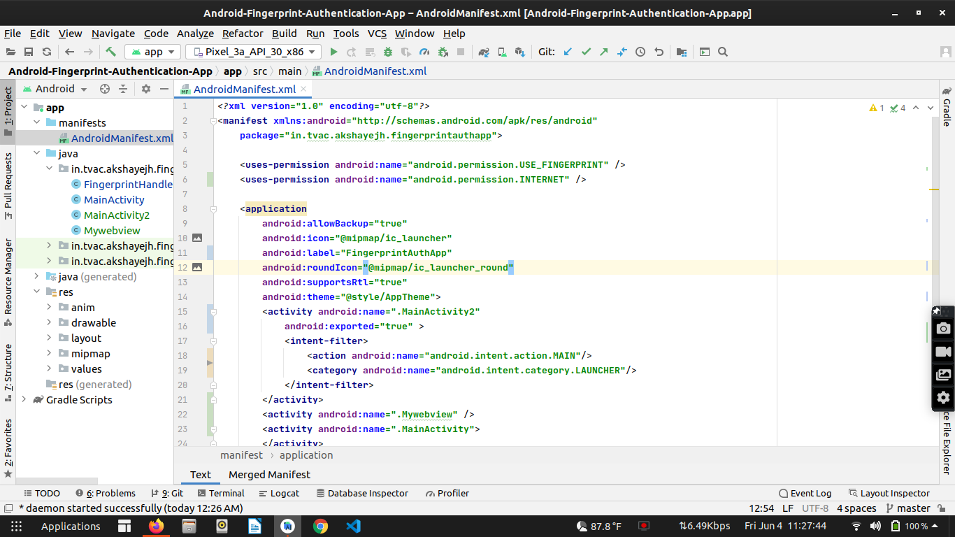
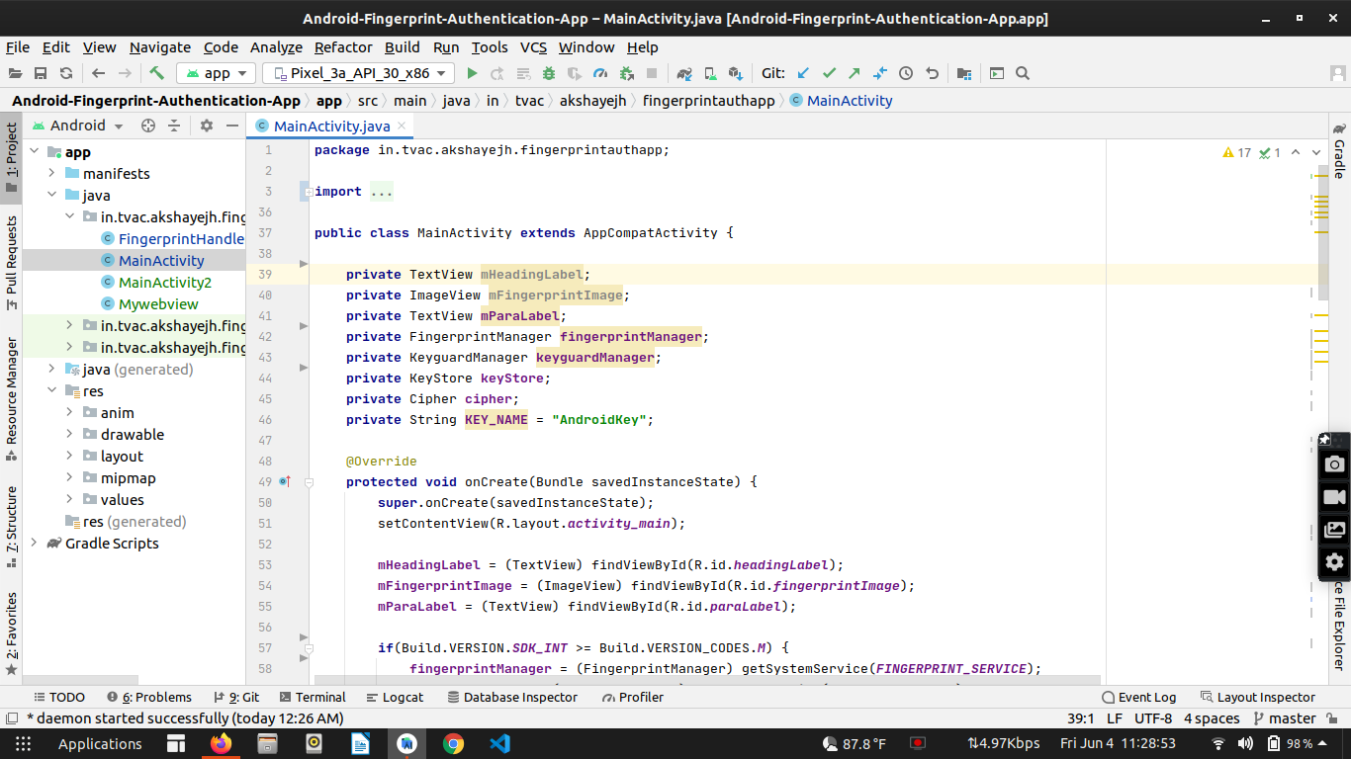
MainActivity.java

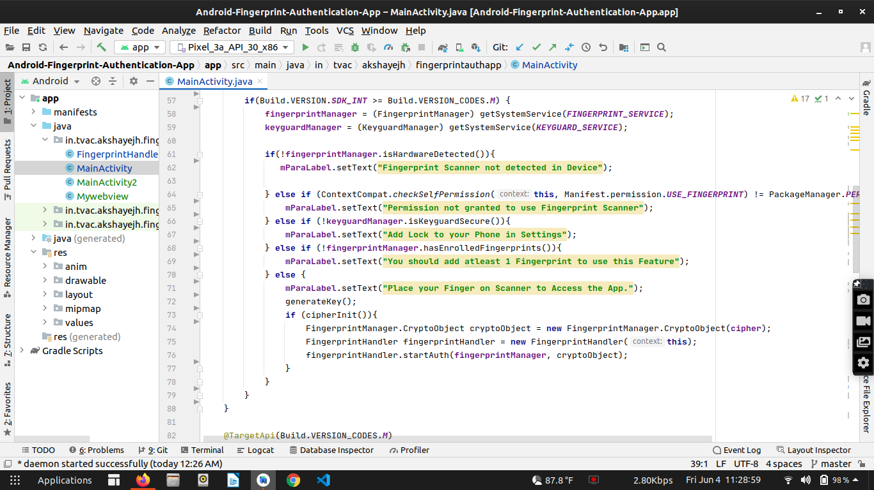
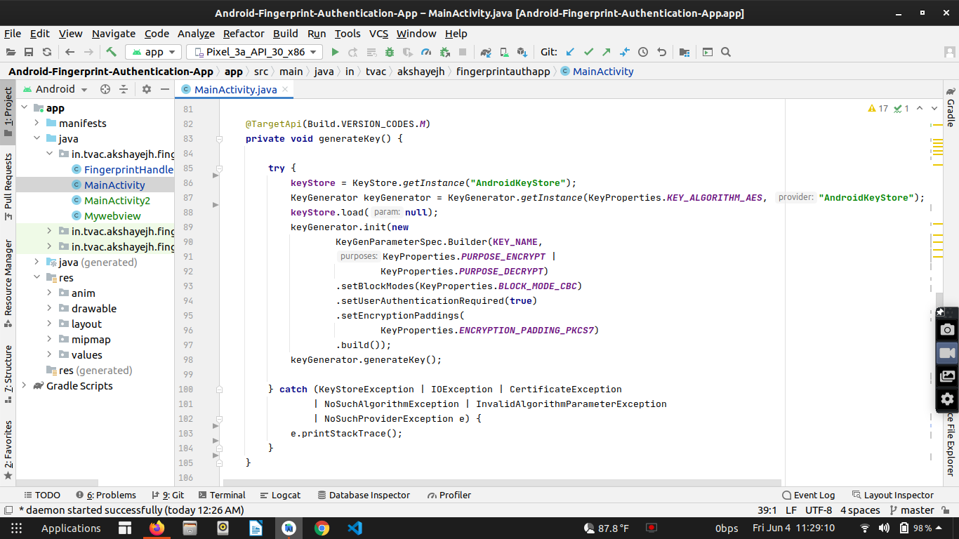

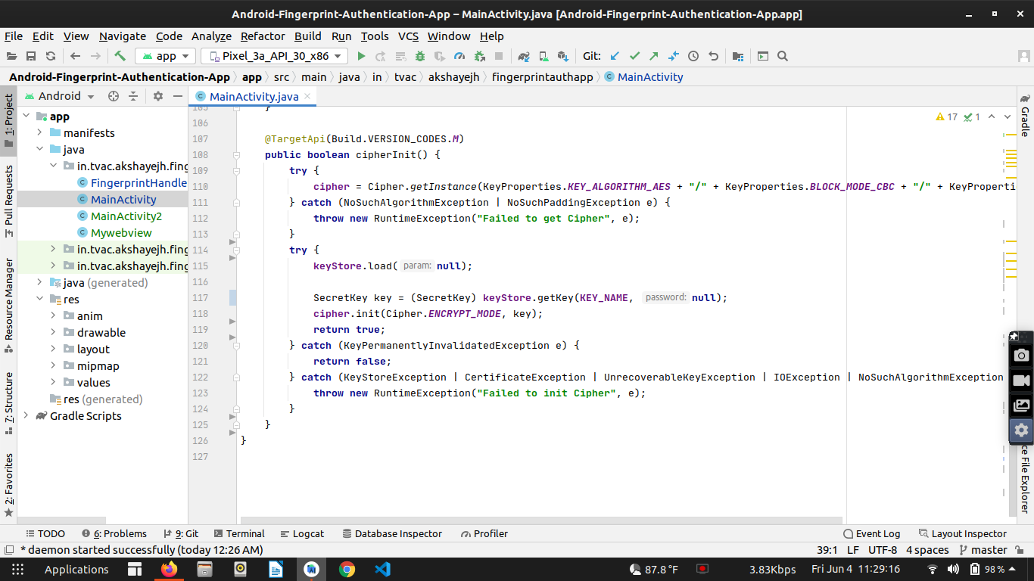

FingerprintHandler.java

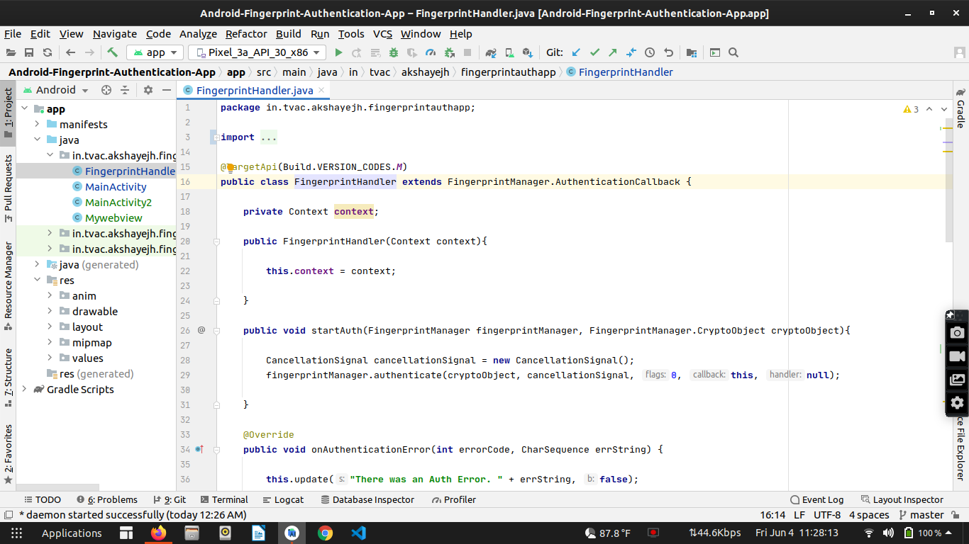

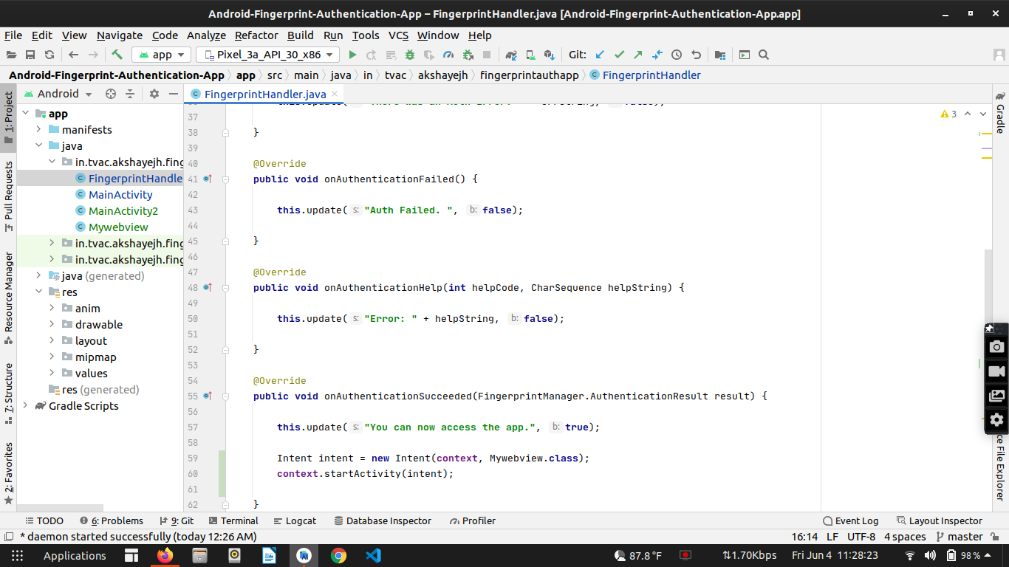

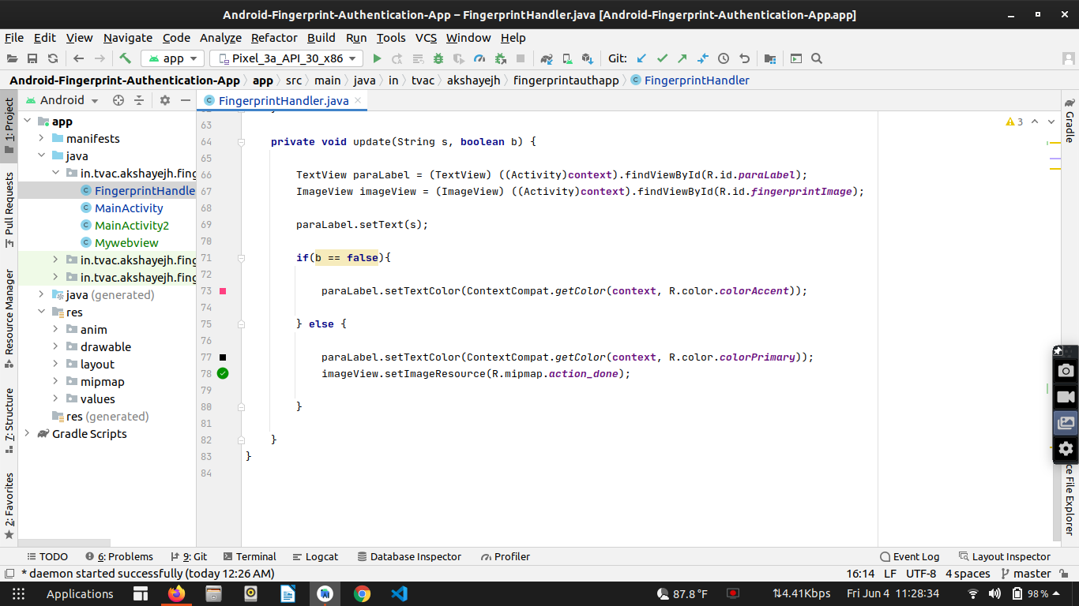

Mywebview.java
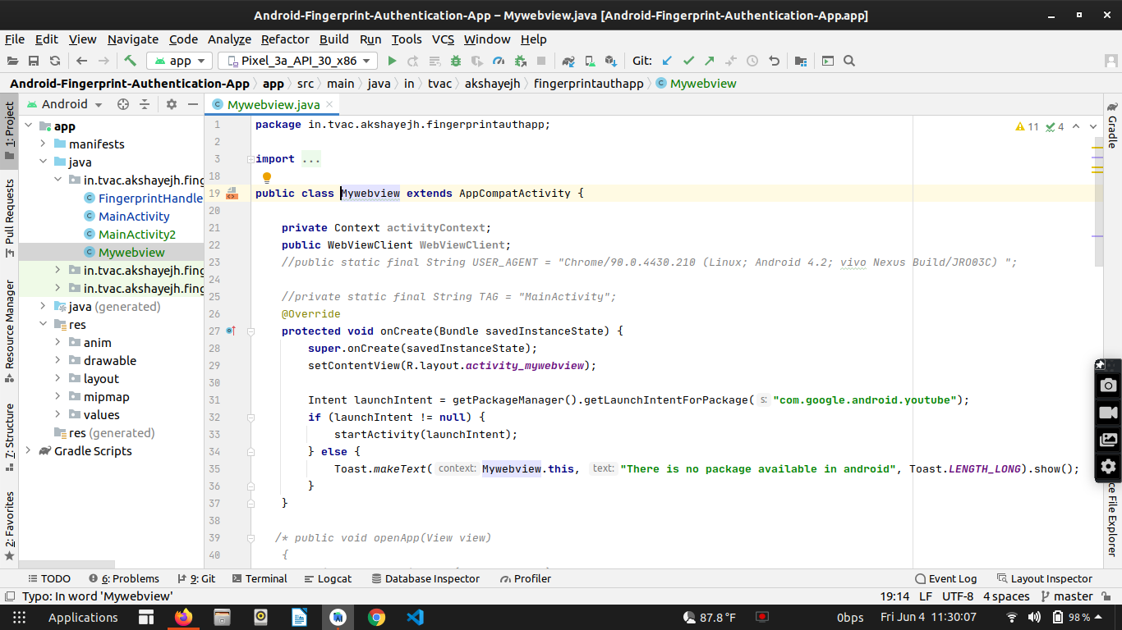

Codes

Manifest.xml

<uses-permission android:name="android.permission.USE_FINGERPRINT" />
<uses-permission android:name="android.permission.INTERNET" />

<activity android:name=".MainActivity2"
android:exported="true" >
<intent-filter>
<action android:name="android.intent.action.MAIN"/>
<category android:name="android.intent.category.LAUNCHER"/>
</intent-filter>
</activity>

activity_main.xml

public class MainActivity extends AppCompatActivity {
private TextView mHeadingLabel;
private ImageView mFingerprintImage;
private TextView mParaLabel;
private FingerprintManager fingerprintManager;
private KeyguardManager keyguardManager;
private KeyStore keyStore;
private Cipher cipher;
private String KEY_NAME = "AndroidKey";
@Override
protected void onCreate(Bundle savedInstanceState) {
super.onCreate(savedInstanceState);
setContentView(R.layout.activity_main);
mHeadingLabel = (TextView) findViewById(R.id.headingLabel);
mFingerprintImage = (ImageView) findViewById(R.id.fingerprintImage);
mParaLabel = (TextView) findViewById(R.id.paraLabel);
if(Build.VERSION.SDK_INT >= Build.VERSION_CODES.M) {
fingerprintManager = (FingerprintManager) getSystemService(FINGERPRINT_SERVICE);
keyguardManager = (KeyguardManager) getSystemService(KEYGUARD_SERVICE);
if(!fingerprintManager.isHardwareDetected()){
mParaLabel.setText("Fingerprint Scanner not detected in Device");
} else if (ContextCompat.checkSelfPermission(this, Manifest.permission.USE_FINGERPRINT) != PackageManager.PERMISSION_GRANTED){
mParaLabel.setText("Permission not granted to use Fingerprint Scanner");
} else if (!keyguardManager.isKeyguardSecure()){
mParaLabel.setText("Add Lock to your Phone in Settings");
} else if (!fingerprintManager.hasEnrolledFingerprints()){
mParaLabel.setText("You should add atleast 1 Fingerprint to use this Feature");
} else {
mParaLabel.setText("Place your Finger on Scanner to Access the App.");
generateKey();
if (cipherInit()){
FingerprintManager.CryptoObject cryptoObject = new FingerprintManager.CryptoObject(cipher);
FingerprintHandler fingerprintHandler = new FingerprintHandler(this);
fingerprintHandler.startAuth(fingerprintManager, cryptoObject);
}
}
}
}
@TargetApi(Build.VERSION_CODES.M)
private void generateKey() {
try {
keyStore = KeyStore.getInstance("AndroidKeyStore");
KeyGenerator keyGenerator = KeyGenerator.getInstance(KeyProperties.KEY_ALGORITHM_AES, "AndroidKeyStore");
keyStore.load(null);
keyGenerator.init(new
KeyGenParameterSpec.Builder(KEY_NAME,
KeyProperties.PURPOSE_ENCRYPT |
KeyProperties.PURPOSE_DECRYPT)
.setBlockModes(KeyProperties.BLOCK_MODE_CBC)
.setUserAuthenticationRequired(true)
.setEncryptionPaddings(
KeyProperties.ENCRYPTION_PADDING_PKCS7)
.build());
keyGenerator.generateKey();
} catch (KeyStoreException | IOException | CertificateException
| NoSuchAlgorithmException | InvalidAlgorithmParameterException
| NoSuchProviderException e) {
e.printStackTrace();
}
}
@TargetApi(Build.VERSION_CODES.M)
public boolean cipherInit() {
try {
cipher = Cipher.getInstance(KeyProperties.KEY_ALGORITHM_AES + "/" + KeyProperties.BLOCK_MODE_CBC + "/" + KeyProperties.ENCRYPTION_PADDING_PKCS7);
} catch (NoSuchAlgorithmException | NoSuchPaddingException e) {
throw new RuntimeException("Failed to get Cipher", e);
}
try {
keyStore.load(null);
SecretKey key = (SecretKey) keyStore.getKey(KEY_NAME, null);
cipher.init(Cipher.ENCRYPT_MODE, key);
return true;
} catch (KeyPermanentlyInvalidatedException e) {
return false;
} catch (KeyStoreException | CertificateException | UnrecoverableKeyException | IOException | NoSuchAlgorithmException | InvalidKeyException e) {
throw new RuntimeException("Failed to init Cipher", e);
}
}
}

FingerprintHandler.java

@TargetApi(Build.VERSION_CODES.M)
public class FingerprintHandler extends FingerprintManager.AuthenticationCallback {
private Context context;
public FingerprintHandler(Context context){
this.context = context;
}
public void startAuth(FingerprintManager fingerprintManager, FingerprintManager.CryptoObject cryptoObject){
CancellationSignal cancellationSignal = new CancellationSignal();
fingerprintManager.authenticate(cryptoObject, cancellationSignal, 0, this, null);
}
@Override
public void onAuthenticationError(int errorCode, CharSequence errString) {
this.update("There was an Auth Error. " + errString, false);
}
@Override
public void onAuthenticationFailed() {
this.update("Auth Failed. ", false);
}
@Override
public void onAuthenticationHelp(int helpCode, CharSequence helpString) {
this.update("Error: " + helpString, false);
}
@Override
public void onAuthenticationSucceeded(FingerprintManager.AuthenticationResult result) {
this.update("You can now access the app.", true);
Intent intent = new Intent(context, Mywebview.class);
context.startActivity(intent);
}
private void update(String s, boolean b) {
TextView paraLabel = (TextView) ((Activity)context).findViewById(R.id.paraLabel);
ImageView imageView = (ImageView) ((Activity)context).findViewById(R.id.fingerprintImage);
paraLabel.setText(s);
if(b == false){
paraLabel.setTextColor(ContextCompat.getColor(context, R.color.colorAccent));
} else {
paraLabel.setTextColor(ContextCompat.getColor(context, R.color.colorPrimary));
imageView.setImageResource(R.mipmap.action_done);
}
}
}

MainActivity2.java

ublic class MainActivity2 extends AppCompatActivity {
ImageView imageView;
Animation animation;
@Override
protected void onCreate(Bundle savedInstanceState) {
super.onCreate(savedInstanceState);
setContentView(R.layout.activity_main2);
imageView = findViewById(R.id.imageView);
animation = AnimationUtils.loadAnimation(getApplicationContext(),R.anim.animation);
try {
imageView.startAnimation(animation);
} catch (Exception e) {
e.printStackTrace();
}
new Handler().postDelayed(new Runnable() {
@Override
public void run() {
Intent intent = new Intent(MainActivity2.this, MainActivity.class);
MainActivity2.this.startActivity(intent);
}
},5500);
}
}

Mywebview.java

public class Mywebview extends AppCompatActivity {
private Context activityContext;
public WebViewClient WebViewClient;
//public static final String USER_AGENT = "Chrome/90.0.4430.210 (Linux; Android 4.2; vivo Nexus Build/JRO03C) ";
//private static final String TAG = "MainActivity";
@Override
protected void onCreate(Bundle savedInstanceState) {
super.onCreate(savedInstanceState);
setContentView(R.layout.activity_mywebview);
Intent launchIntent = getPackageManager().getLaunchIntentForPackage("com.google.android.youtube");
if (launchIntent != null) {
startActivity(launchIntent);
} else {
Toast.makeText(Mywebview.this, "There is no package available in android", Toast.LENGTH_LONG).show();
}
}

output
